Appetizers
Vegetable Samosas
Cripsy turnovers stuffed with green peas, potatoes and roasted cashew nuts $4

Vegetable Pakoras
Freshly seasoned vegetable fritters $4

Samosa Chaat
Two samosas drizzled with a yogurt, tamarind-mint puree topped with a combination of fresh fruits, chickpeas, tomato and potato noodles $7

Papadi Chaat
Crispy wheat chips drizzled with a yogurt, tamarind-mint puree topped with a combination of fresh fruits, tomato and potato noodles $7

Chicken 65
Deep fried chicken marinated in ginger garlic paste and sauteed in chefs speical sauce and herbs $9

Chicken Soup
Chefs special chicken soup served with croutons $5

Tomato Soup
Chefs special tomato soup served with croutons $5

Green Salad
Baby spinach, spring mix, purple onion, radish, and cherry tomato drizzled with chefs special dressing topped with candied walnuts $5

Kadahi Items (Served with Basmati rice)
Fresh onion, tomato, and bell pepper, cooked in a special kadahi sauce, and sauteed with your choice of:
Chicken $14
Lamb $15
Shrimp $14
Paneer $12

Biryani (Special Rice Dish)
Basmati rice cooked with saffron, special biryani seasoning and herbs, cooked plain or with your choice of:
Vegetable $10
Chicken $12
Lamb Biryani $14
Shrimp $13
Plain $5

Chicken Dishes (Served with Basmati Rice)
Chicken Tikka Masala
Chicken breast marinated in herbs, G-G paste, cooked with tomato, onion and delicious cream sauce $12

Butter Chicken
Boneless chicken thighs marinated in herbs, G-G paste, cooked with tomato, onion, cashew nuts, cream sauce and herbs $12

Chicken Curry
Chicken breast cooked with tomato-onion puree and herbs $11

Chicken Vindaloo
Chicken breast cooked with a tomato-onion puree with potatoes and herbs $12

Exotic Curry
Chefs special dish prepared with lamb, chicken breast, and vegetables in a curry sauce and herbs $12

Chicken Korma
Chicken breast cooked with onion-tomato puree, cashew nuts, coconut, and a ricotta cream sauce $12

Chicken Palak
Chicken breast cooked with a spinach puree, cumin, garlic and madurai garam masala with a touch of cream $12

Lamb Dishes (Served with Basmati Rice)
Lamb Tikka Masala
Lamb cube marinated in herbs, G-G paste, cooked with tomato, onion and delicious cream sauce $15

Lamb Curry
Lamb cube cooked with tomato-onion puree and herbs $14

Lamb Vindaloo
Lamb cube cooked with a tomato-onion puree with potatoes and herbs $15

Lamb Korma
Lamb cube cooked with onion-tomato puree, cashew nuts, coconut, and a ricotta cream sauce $15

Lamb Palak
Lamb cube cooked with a spinach puree, cumin, garlic and madurai garam masala with touch of cream $15

Seafood Dishes (Served with Basmati Rice)
Fish Curry
Tilapia cooked with mustard seed, curry leaves, and coconut milk in a curry sauce and herbs $14

Shrimp Curry
Tender shrimp with mustard seed, curry leaves, coconut milk in a curry sauce and herbs $14

Shrimp Tikka Masal
Tender shrimp marinated in herbs, G-G paste, cooked with tomato, onion and delicious cream sauce $14

Shrimp Vindaloo
Tender shrimp cooked with a tomato-onion puree with potatoes and herbs $15

Shrimp Jalfrezi
Tender shrimp cooked with assorted vegetables, onion seed, unique jalfrezi sauce and herbs $15

Vegetarian Dishes (Served with Basmati Rice)
Palak Paneer
Spinach puree and homemade cheese cooked with spices and herbs with a touch of cream $12

Matar Paneer
Organic green peas and homemade cheese cooked with spices and herbs with a touch of cream $12

Paneer Tikka Masala
Homemade cheese cooked in delicious cream sauce with tomato, onion, G-G paste and herbs $12

Aloo Palak
Spinach puree and potato cooked with spices and herbs with a touch of cream $11

Aloo Gobi
Cauliflower and Idaho potato cooked with cumin seed, cinnamon powder and herbs $11

Vegetable Korma
Assorted Vegetables cooked with onion-tomato puree, cashew nuts, coconut, and a ricotta cream sauce $12

Malai Kofta
Idaho potato, vegetable and homemade cheese dumplings cooked with five spices, onion-tomato puree, cashew nuts, coconut, and ricotta cream sauce $12
Bengan Bharta
Char-smoked eggplant cooked with spices and herbs with a touch of cream $12

Mix Vegetable Curry
Fresh Assorted vegetables cooked with tomato-onion puree and herbs $10

Bhindi Masala
Fresh okra cooked with tomato, onion, and herbs $10

Chana Masala
Chick peas cooked with tomato, onion and herbs $9

Dal
Assorted lentils cooked with tomato, onion and herbs $9

Tandoor Specialties
Tandoori Chicken
Chicken leg quarter marinated overnight in homemade yogurt, lemom juice and garam masala cooked in traditional clay oven $13

Chicken Shish Kebab
Ground Chicken with onion, herbs molded on the skewers cooked in traditional clay oven $14

Malai Chicken
Chicken breast marinated in cream cheese, cardamom, cumin powder and herbs cooked on the skewer in traditional clay oven $13

Breads (Cooked in Tandoor)
Plain Naan
Leavened bread freshly cooked in clay oven $2

Garlic Naan
Naan with garlic and cilantro $2.50

Cheese Naan
Naan stuffed with grated cheese $4

Peshawari Naan
Naan stuffed with dry fruits and nuts $5

Aloo Naan
Naan stuffed with idaho potato, cilantro, roasted cumin $4

Tandoori Roti
Unleavened whole wheat bread cooked in clay oven $2
Nepali Thali
Non-Vegeterian Thali
Choice of chicken or lamb curry served with dal, mix vegetable curry, rice pudding and salad $15

Vegeterian Thali
Mix Vegetable curry, dal, rice pudding, and salad served with chef's special vegeterian dish $14

MoMo (Nepalese Dumpling)
Chicken MoMo
Spiced ground chicken, cilantro, onion with herbs wrapped in dumping wrapper, steamed to perfection and served with a roasted tomato-sesame pepper chutney (10 Pieces) $10

Desserts
Homemade mango ice cream $4
Gulab Jamun $4
Masala Kheer $4

Side Dishes
Tikka Sauce $5
Raita $3
Homemade yogurt $3
Papadam $2.50
Mango Chutney $2
Mixed Pickle $2

Beverages
Soda (Coke, Diet Coke, Sprite, Dr. Pepper) $1.75
Salted or Sweet Lassi $2
Mango Lassi $3
Strawberry Lassi $3
Masala Chai Tea $3
Masala Black Tea $2.50
Coffee $2.5

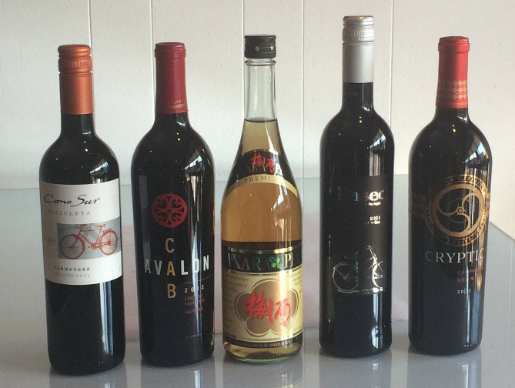

Tandoor cooking is one of the highlights of Indian cuisine. A cylindrical beehive shaped clay oven- best described as a cross between a horizontal plan masonry oven and a makeshift earth oven- is used in baking and barbecuing, not just in India, but also Turkey, Iran, Armenia, Pakistan, Uzbekistan, Central Asia, as well as Nepal and Bangladesh. The heat of Tandoor was traditionally generated by a charcoal or wood, burning at its base, the inside temperature soaring as high as 480 degrees C (900 degrees F).
The cooking method of a Tandoor can be best described as a combination of radiant heat, hot-air convection and smoking created by the natural juices that drip on the charcoal, exposing the food to live-fire and smoke.
In modern gas Tandoors, the same effect is achieved by arranging fire-proof earthen balls at the base of the burner. Tandoor is used to make breads, kebabs, tandoori meats and vegetables. The word Tandoori is the adjective meaning -pertaining to the Tandoor- and is used to describe a dish cooked in it.

